***1.INTRODUCTION***

***1.1*Overview**

**Exploring World’s Top YouTube Channels by creating Problem Definition, Design Thinking.**

**1.2Purpose**

**YouTube is an information disseminating platform for students. It’s the perfect place to learn and gain expertise, it is a user-friendliness. Easy earning is at he very top of the list of YouTube benefits for Vloggers.**

***2.PROBLEM DEFINITION & DESIGN THINKING***

***2.1EMPATHY MAP***

|  |
| --- |
|  |
|  |  |

***2.2 IDEATION BRAINSTORMING AND PRIORITIZATION***

|  |
| --- |
|  |
|  |  |

***3.RESULT***

**Published Exploring World’s Top YouTube Channels, which includes Rank wise channels, Number of channels with brand, Channels with subscribers, Country wise subscribers.**

**DASHBOARD 1**

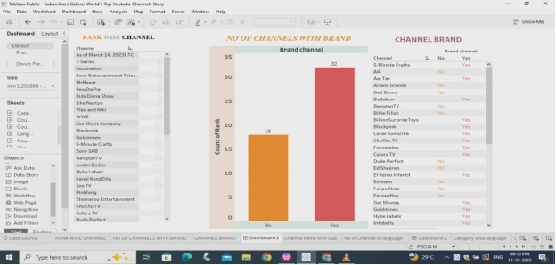

**DASHBOARD 2**

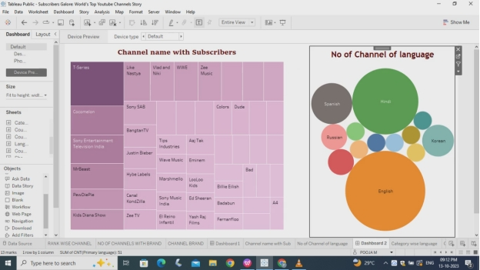

**DASHBOARD 3**

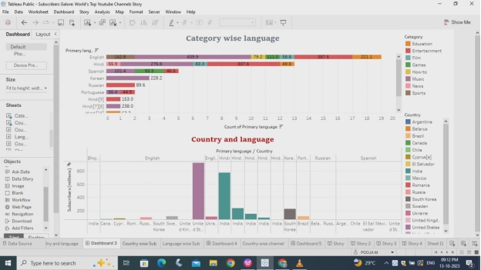

**DASHBOARD 4**

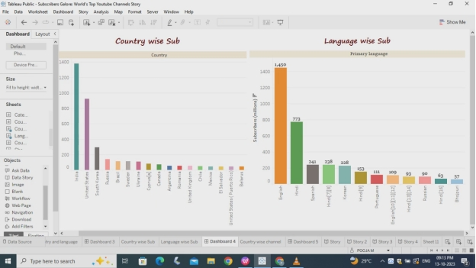

**DASHBOARD 5**

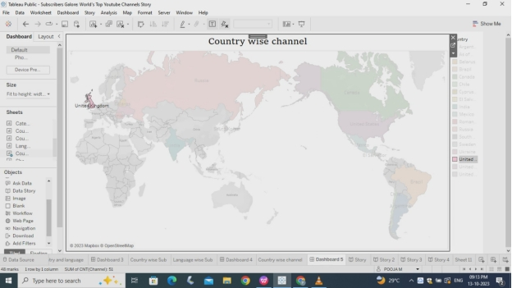

**STORY**

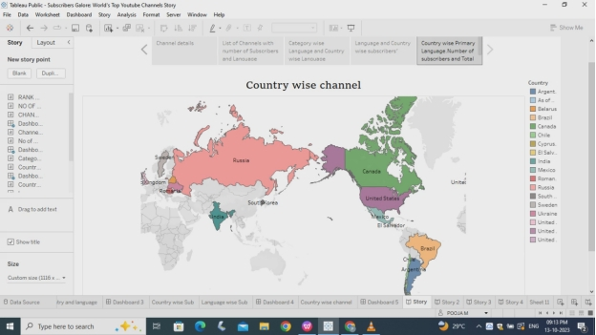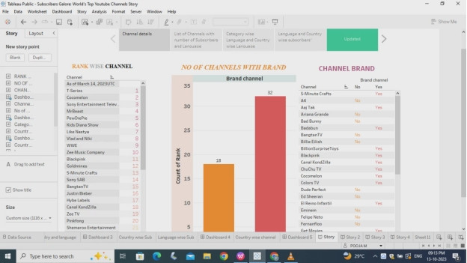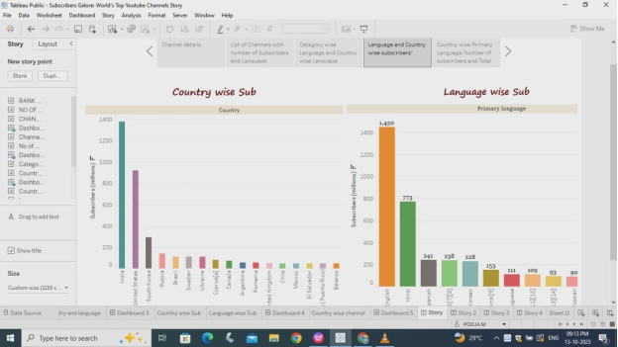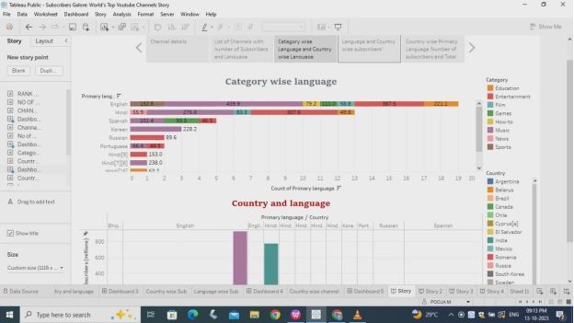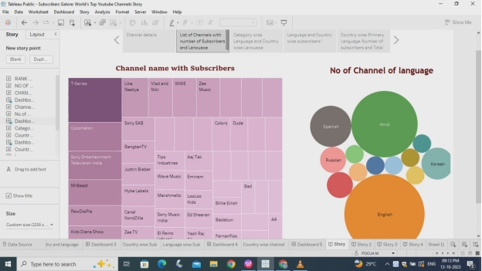

***4.ADVANTAGES & DISADVANTAGES***

***ADVANTAGES***

* **Gives you the opportunity to earn money through your videos.**
* **An easy way to share information.**
* **YouTube videos a great tool for engaging students in learning.**

***DISADVANTAGES***

* ***A lot of distraction.***
* ***Little difficult to start earning.***

***5.APPLICATIONS***

* **YouTube is a video sharing service where users can watch, like, share, comment and upload their own videos.**
* **It offers informative and engaging documentaries.**
* **Generate interactions for significant communications.**

***6.CONCLUSION***

**By Exploring World’s Top YouTube channels are useful for higher studying students and they can gain knowledge about it.**

***7.FUTURE SCOPE***

**If YouTube continues on the current path, the future will include more streaming, more eCommerce initiatives and more immersive experiences.**